IIS (deemed to be University), Jaipur



Multi-Agent AI Assessment System

B.Sc.(H) in Data Analytics and Artificial Intelligence

Supervisor (Internal):  Dr. Ruchi Nanda  Associate Professor  Dr. Amita Sharma  (Assistant Professor)  Department of CS&IT | Submitted by:  Ms. Teena Sharma  Enroll no.: IISU/2023/ADM/35484  Roll no.:232021

TABLE OF CONTENTS

S.No. | Content | Page no.
 | Acknowledgement | I
 | Abstract | II
1 | Introduction
 | - Problem Statement  - Significance of Problem  - Objectives  - Tasks identified | 5 – 7
2 | Tools and Technology | 8
3 | Tasks Description
 | - Methodology  - Interpretations  - Learning Outcomes | 9 -19
4 | Conclusion | 20
5 | References | 21
6 | Annexure | 22 – 30

ACKNOWLEDGEMENT

I would like to express my sincere gratitude to everyone who supported and guided me throughout the development of this project. This project provided me with valuable exposure to AI-based system development, multi-agent architectures, web application development, and real-world academic assessment workflows.

I am deeply thankful to my faculty members for their continuous guidance, support, and encouragement throughout the project period. During this project, I worked on building IIS Edu Grade AI — a Multi-Agent AI Assessment System — which helped me greatly improve my understanding of Natural Language Processing, Bloom's Taxonomy, Flask web development, database management, and AI-powered feedback generation.

This project significantly enhanced my technical, analytical, communication, and problem-solving skills while giving me practical exposure to real-world software development practices. The experience of designing, developing, testing, and documenting a full-stack AI-powered web application has been truly rewarding.

I would like to express my heartfelt gratitude to IIS (Deemed to be) University for providing me with the academic environment, resources, and training that enabled me to take on and successfully complete this project. I extend my sincere thanks to my teachers Dr. Anubha Jain (Director), Dr. Ruchi Nanda (Associate Professor), Dr. Navneet Sharma (Head of Department), Dr. Amita Sharma (Assistant Professor), IISU for their unwavering support and guidance throughout my journey. Their dedication to imparting knowledge and fostering my intellectual growth has been truly invaluable.

Finally, I would like to extend my heartfelt thanks to my family and friends for their constant support and encouragement throughout this project. Their belief in me, their motivation, and their understanding during challenging times made a significant difference in my ability to succeed and deliver this work to the best of my ability.

This project has expanded my perspective on the application of Artificial Intelligence in education and has strengthened my enthusiasm for Software Development and AI-based solutions. It has been an honor to represent IIS (Deemed to be) University through this work.

I
ABSTRACT

Manual evaluation of exam papers is one of the most time-consuming and inconsistent tasks in the education system. Teachers spend a large amount of time grading student answers and analysing question paper quality, with no standard system to ensure fairness and transparency. This technical project focuses on developing a web-based Multi-Agent AI Assessment System that automates question paper analysis and student answer evaluation using artificial intelligence, while providing explainable and transparent results to teachers.

The system uses Claude AI Vision API as its AI engine, which reads uploaded question papers as images or PDFs using Vision AI and extracts questions automatically. Four AI agents work together — Agent 1 analyses each question for Bloom's Taxonomy level and syllabus match, Agent 2 extracts expected keywords from the question, Agent 3 evaluates student answers semantically, and Agent 4 acts as the final judge combining all scores to produce a final grade and feedback.

The backend is built using Python and Flask, the frontend uses HTML, CSS, and JavaScript, and all data is stored in a SQLite database. Teachers can download complete evaluation reports in Excel format. The system covers Semester 5 subjects for both BCA and BSc(H) Data Analytics and AI courses at IIS University. A key feature of this system is Explainable AI (XAI) — it does not just give a score but explains why a question is at a certain Bloom's level, which keywords were found or missing, and what the student did well or needs to improve.

II

1. INTRODUCTION

In most universities, checking question papers and evaluating student answers is done manually by teachers. This takes a lot of time and can lead to inconsistent results since different teachers may grade the same answer differently. There is no standard system to verify whether questions match the syllabus or test higher-order thinking skills. India's National Education Policy (NEP 2020) promotes Outcome-Based Education (OBE) which focuses on measurable learning outcomes and cognitive skill development.
AI is now making it possible to solve these problems in education. Hwang et al. (2023) showed that AI can help evaluate questions aligned with Bloom's Taxonomy. Gavhane and Pagare (2025) used NLP to automatically classify questions by cognitive level. Shanto et al. (2025) proposed a generative AI framework to support outcome-based learning. Hui (2025) showed how Bloom's Taxonomy combined with AI improves cognitive development in students.
At IIS (Deemed to be University), Jaipur, we built IIS Edu Grade AI for Semester 5 students of BCA and BSc(H) Data Analytics and AI courses. The system reads uploaded question papers using Vision AI, evaluates student answers through a four-agent pipeline, measures Course Outcome attainment, and gives personalized feedback to students through a separate student login.

1.1 Problem Statement
Manual evaluation of exam papers is time-consuming and inconsistent. Teachers spend a large amount of time checking whether questions match the syllabus, identifying their cognitive level, and grading student answers one by one. Different teachers may grade the same answer differently, leading to unfair results. There is no automated system at IIS University that can analyze question papers, detect Bloom's Taxonomy levels, evaluate student answers intelligently, and provide transparent and explainable feedback to both teachers and students.

1.2 Significance of Problem
With large class sizes and multiple subjects, teachers struggle to maintain quality in evaluation. Question papers sometimes include questions outside the syllabus or questions that only test memory rather than higher-order thinking. This project brings AI into the assessment process by automatically detecting Bloom's Taxonomy levels, checking syllabus coverage, evaluating answers using keyword matching and semantic understanding, and measuring Course Outcome attainment as per NBA standards. The system ensures every student is evaluated on the same standard with explainable and transparent results.

1.3 Objectives
- To build a web-based system that automatically extracts and analyses CA question papers using Vision AI and detects Bloom's Taxonomy levels (L1–L6).
- To evaluate student answers using a four-agent AI pipeline combining keyword scoring and semantic understanding, generating final marks out of 15.
- To measure Course Outcome (CO) attainment on a 0–5 scale aligned with NBA accreditation standards.
- To provide role-based access for teachers and students, where students can independently view their personalized AI feedback.

1.4 Tasks Identified

- Dataset and Syllabus Setup
Identified all Semester 5 subjects for BCA and BSc(H) Data Analytics and AI courses. Mapped each subject to its Unit 1 and Unit 2 topics as per the IIS University CA exam format for syllabus verification.

- AI Agent Design
Designed four AI agents with specific roles — Vision AI for question extraction, keyword extractor, semantic evaluator, and final judge — each handling a separate part of the evaluation pipeline.

- Backend and Database Development
Built the complete backend using Python and Flask, including all routes, database logic, session management, and Anthropic Claude API integration. SQLite database auto-generates on first run with four tables.

- Frontend Development
Designed all web pages including home, login, register, and assessment tabs using HTML, CSS, and JavaScript following IIS University's maroon and gold color theme.

- Role-Based Access Implementation
Added separate login and registration for teachers and students. Teachers access all four tabs while students can only view their own feedback through the Feedback Generator.

- Answer Evaluation Pipeline
Built the complete answer evaluation flow where a student's answer sheet is uploaded as a PDF, scanned page by page, and evaluated through all four agents to produce keyword score, semantic score, final marks, grade, and feedback.

- Testing and Deployment
Tested the system with real Semester 5 question papers and student answer sheets. Deployed on a local Flask server accessible via browser at http://127.0.0.1:5000.

2. TOOLS AND TECHNOLOGIES

- Python 3.11
Python was the main programming language used for the entire backend. It handled all routing, database operations, AI API calls, file processing, and Excel generation.

- Flask
Flask was used as the web framework to build the backend server. It managed all routes such as /login, /register, /assess, and /answer-evaluator, handled sessions for user authentication, and connected the frontend with the AI logic.

- Google Gemini 2.0 Flash API
Gemini 2.0 Flash was used as the core AI engine for all four agents. It processed question paper images using Vision AI, detected Bloom's Taxonomy levels, extracted keywords, and evaluated student answers semantically.

- HTML5, CSS3 and JavaScript
The complete frontend was built using plain HTML, CSS, and JavaScript without any heavy framework. All pages follow IIS University's official maroon and gold color theme.

- SQLite
SQLite was used as the database. It auto-creates on first run and stores user accounts, question analysis results, teacher feedback, and student evaluation records.

- OpenPyXL
OpenPyXL was used to generate downloadable Excel reports containing question analysis data and student evaluation results with all scores, grades, and feedback.

- Chart.js
Chart.js was used to display a visual bar chart showing concept coverage in the answer evaluator — which concepts were covered and which were missing in the student's answer.

- Pillow
Pillow was used for image processing when question papers were uploaded as image file

3. 1 Methodology

The system follows a step-by-step pipeline starting from user login, then question paper upload, AI-based question extraction and analysis, student answer input, multi-agent evaluation, and finally report generation

1. Dataset and Syllabus Setup

Before building the system, all Semester 5 subjects for BCA and BSc(H) Data Analytics and AI courses were identified and mapped to their Unit 1 and Unit 2 topics as per IIS University CA exam format. This mapping was hardcoded into the backend so the system can automatically verify whether each question belongs to the correct syllabus unit when a question paper is uploaded.
Course | Subjects
BCA Sem 5 | Ethical Hacking, Web Application Development-III, Fundamentals of Testing, Mobile Application Development, Machine Learning, Cloud Computing, Presentation Skills
BSc(H) Sem 5 | Operations Research, Linear Algebra, Data Visualization, Computer Vision and IoT, Big Data and Text Mining, Presentation Skills

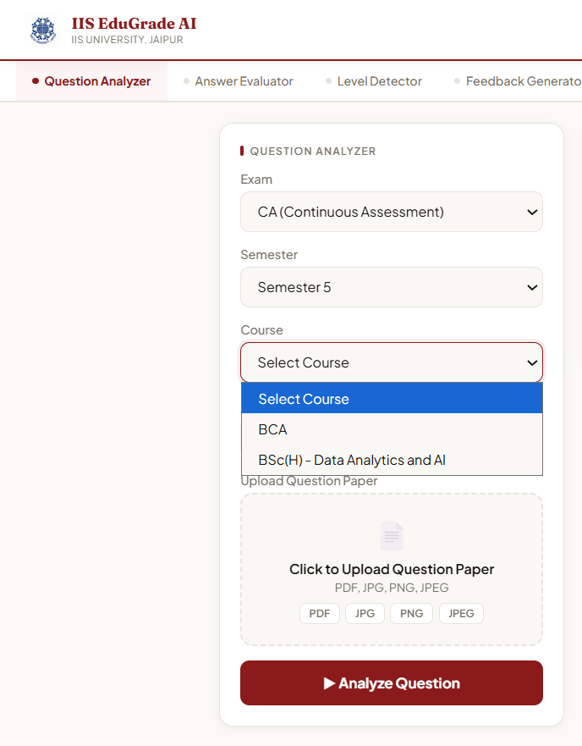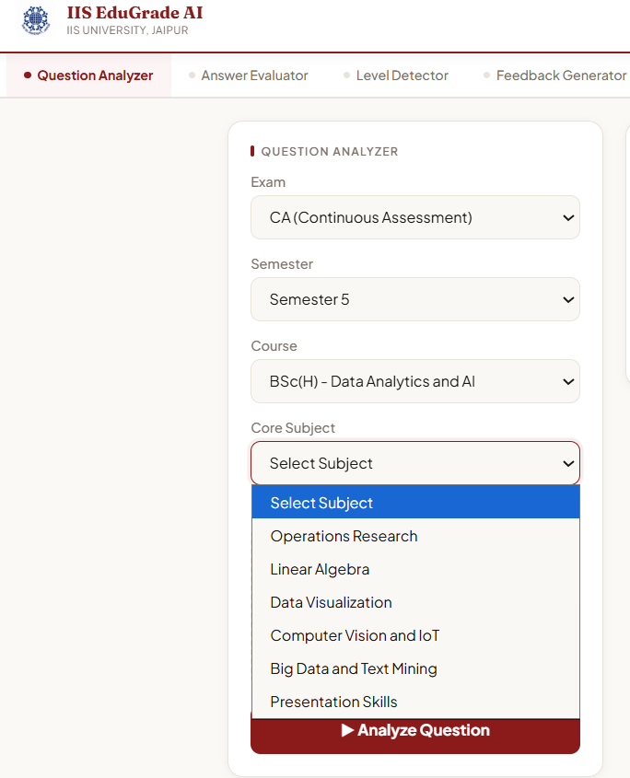

Figure 1: Subject Dropdown — Course and Subject Selection

2. AI Agent Design

Four AI agents were designed using the Anthropic Claude API, each handling one specific task in the evaluation pipeline.
- Agent 1 — Vision AI: Reads the uploaded CA question paper as image or PDF and extracts all 4 questions automatically without any manual typing.
- Agent 2 — Keyword Extractor: Takes each question and identifies the must-have keywords and concepts that a correct answer should contain.
- Agent 3 — Semantic Evaluator: Reads the student's answer and evaluates it for understanding, depth, and accuracy beyond just keyword matching.
- Agent 4 — Orchestrator: Combines keyword score and semantic score using the formula below and produces final marks, grade, and AI feedback.

Final Score = (60% × Keyword Score) + (40% × Semantic Score)

Final Marks per Question = (Final Score / 10) × 5

Total Marks = Sum of 3 attempted questions out of 15

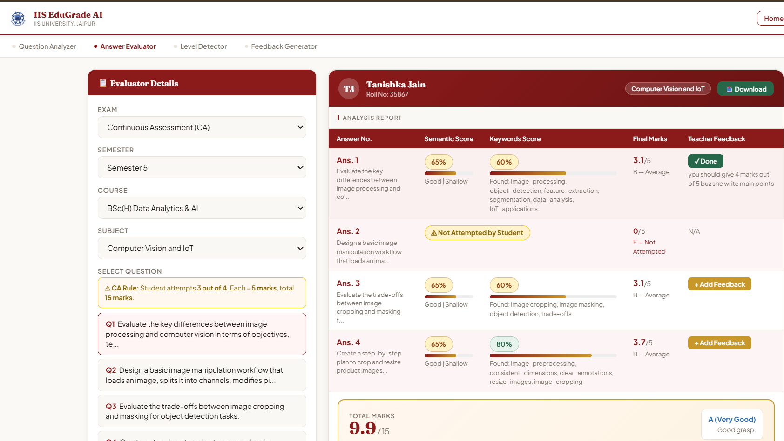

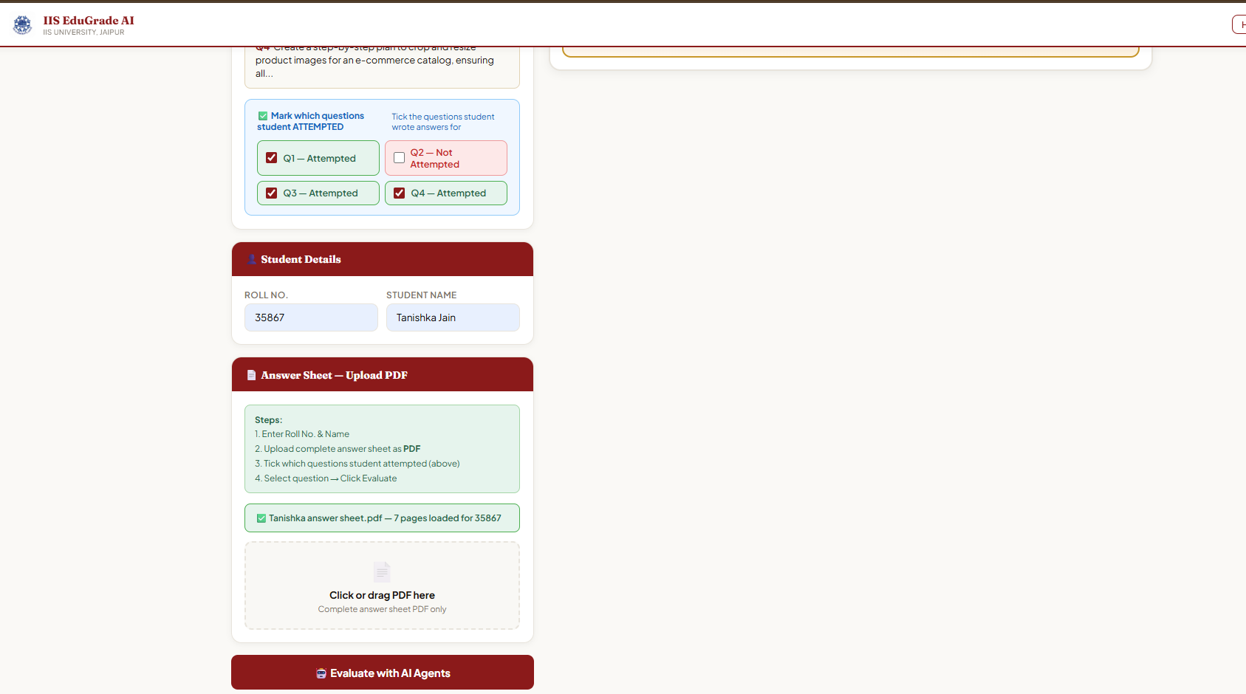

Figure 2: Answer Evaluator — Analysis Report Table showing Semantic Score, Keyword Score, Final Marks

3. Backend and Database Development

The complete backend was built using Python and Flask. Flask manages all routes, user sessions, database operations, and Claude API calls. The SQLite database auto-generates on first run with the following tables:
Table | What it stores
users | Name, department, course, email, password hash, role, roll number
analyses | Question analysis results — BT level, syllabus, difficulty, quality
feedback_log | Teacher BT level and written feedback on questions
evaluations | Student answer scores — keyword, semantic, final marks, grade, AI feedback

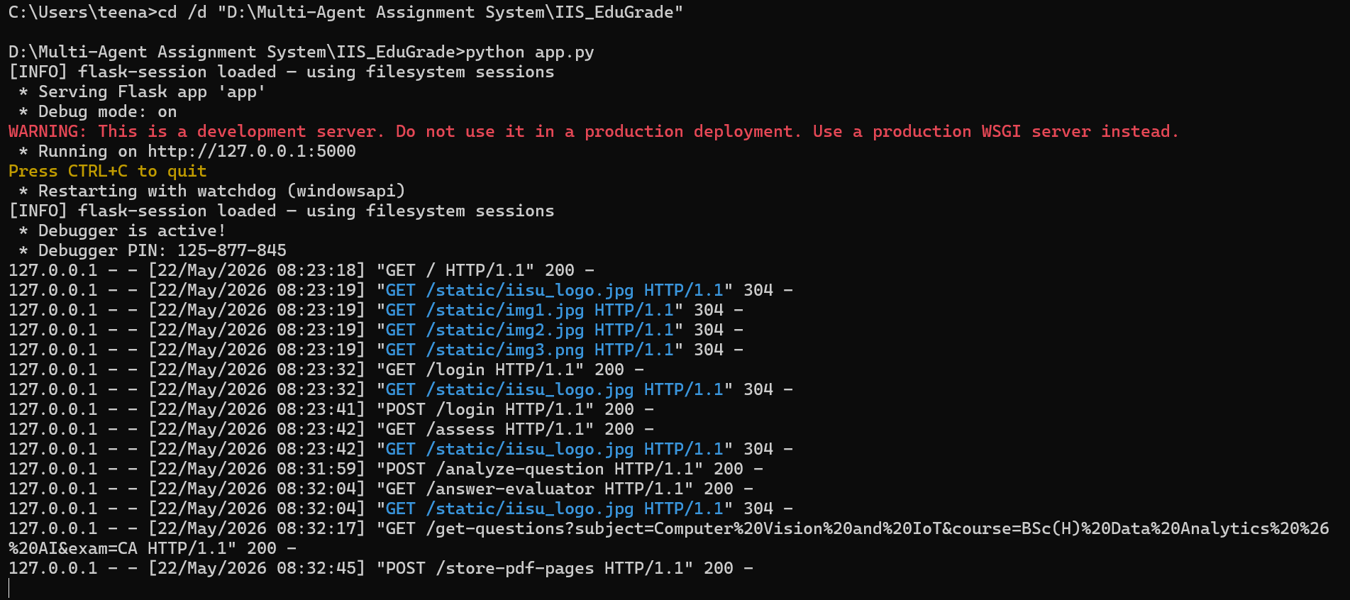

Figure 3: Terminal — app.py running on local server

4. Frontend Development

All pages were designed using HTML, CSS, and JavaScript. The system has the following pages — Home, Login, Register, and the main Assessment page with four tabs: Question Analyzer, Answer Evaluator, Level Detector, and Feedback Generator. The complete design follows IIS University's official maroon (#8B1A1A) and gold (#C8972A) color theme using Fraunces and Plus Jakarta Sans fonts.



Figure 4: Home Page

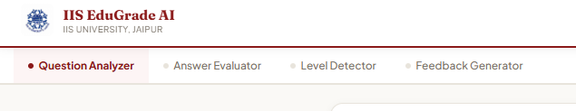

Figure 5: Assessment Page — Four Tabs

5. Role-Based Access

Separate registration and login were built for teachers and students. Teachers Create Account with name, department, course, email, and password. Students register with an additional roll number field. On login, Flask session stores the user's role. Based on role, access is restricted as follows:
Role | Access
Teacher | Question Analyzer, Answer Evaluator, Level Detector, Feedback Generator
Student | Feedback Generator only — shows only their own feedback based on roll number

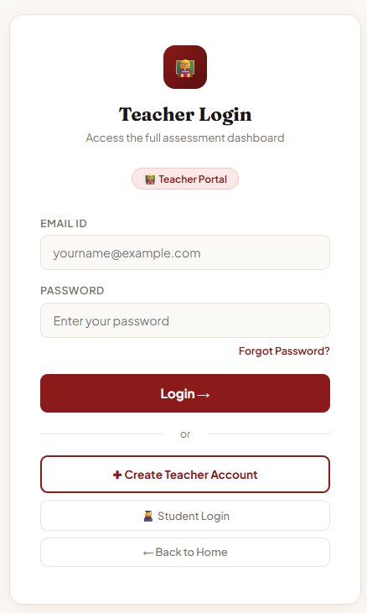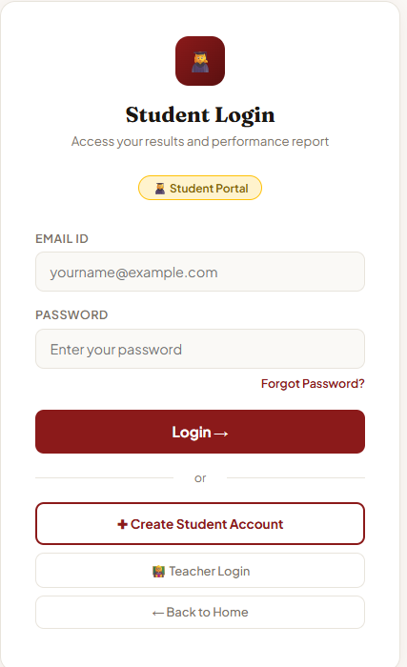

Figure 6: Login Page

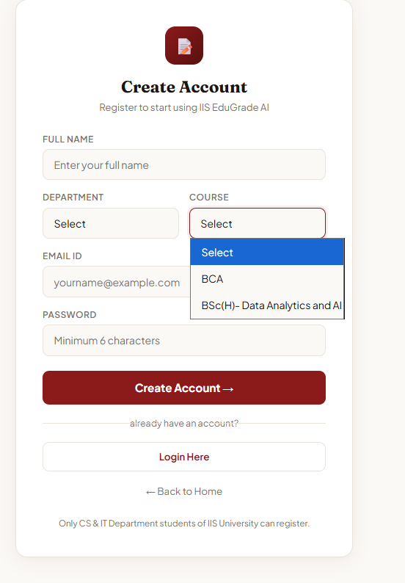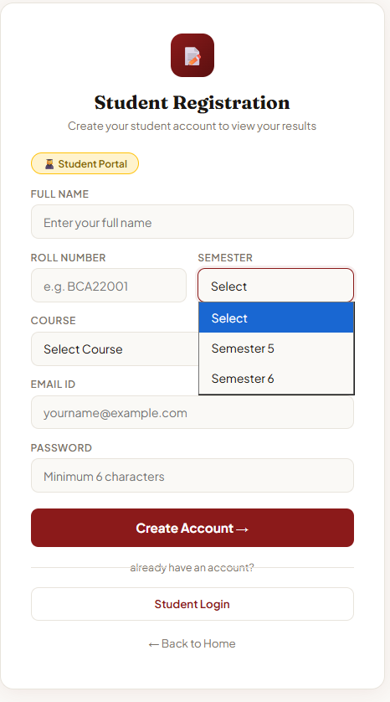

Figure 7: Create Account Page

6. Answer Evaluation Pipeline

The teacher uploads the student's answer sheet as a multi-page PDF. The PDF is uploaded once and all pages are scanned together. The system reads the left side of each page to detect which answer is written where — Answer 1, Answer 2, Answer 3. As per CA rule, the paper has 4 questions but the student attempts any 3. If a question is not attempted, it shows 0 marks. Each detected answer is passed through Agents 2, 3, and 4. The result is displayed in a student card showing name, roll number, subject, answer-wise scores, and total marks out of 15 with grade.
Grade | Marks Range | Performance
O — Outstanding | 13.5 – 15 | Excellent performance
A — Good | 10.5 – 13.4 | Good understanding
B — Average | 7.5 – 10.4 | Needs improvement
C — Below Average | Below 7.5 | Requires attention

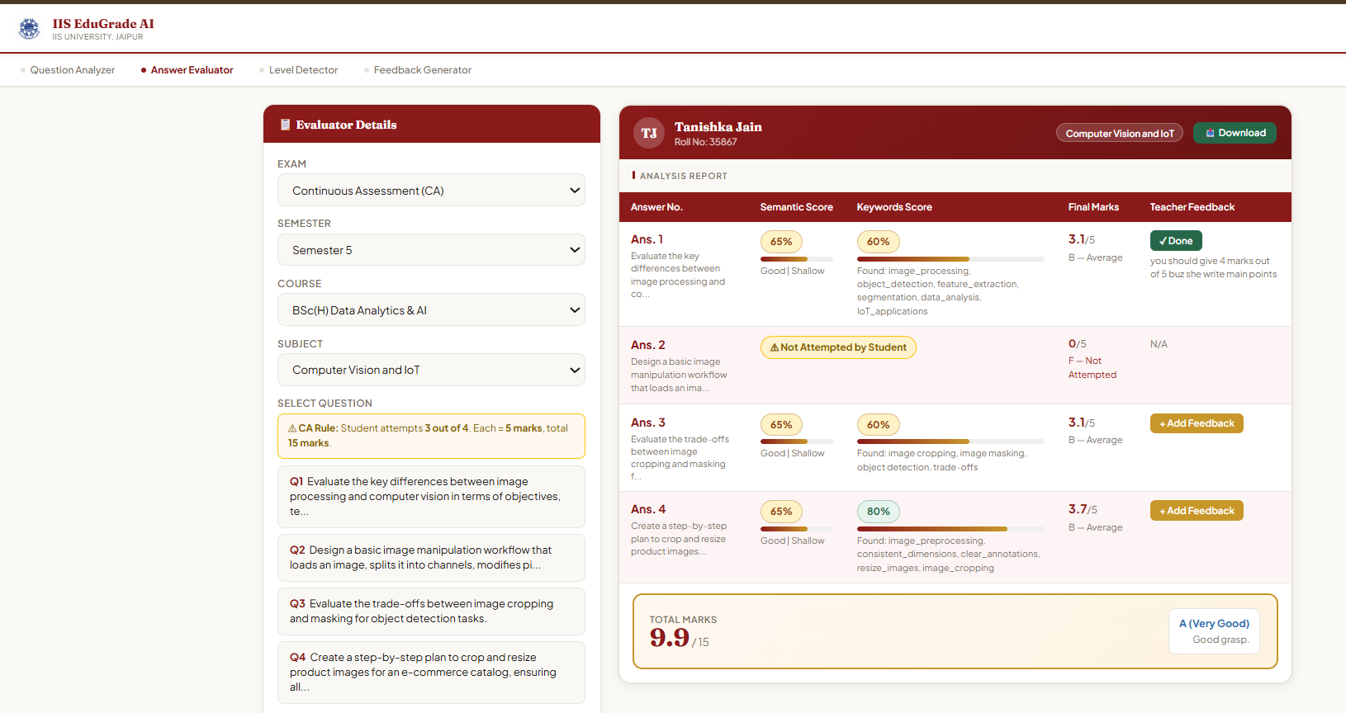

Figure 8: Answer Evaluator — Student Card with Total Marks and Grade

3.7 Testing and Deployment

The system was tested using real Semester 5 question papers uploaded as images and PDFs, and student answer sheets uploaded as scanned PDFs. All features including question extraction, BT level detection, syllabus check, answer evaluation, CO attainment report, student feedback, and Excel download were tested and verified. The application runs locally by executing python app.py and is accessible in the browser at http://127.0.0.1:5000.

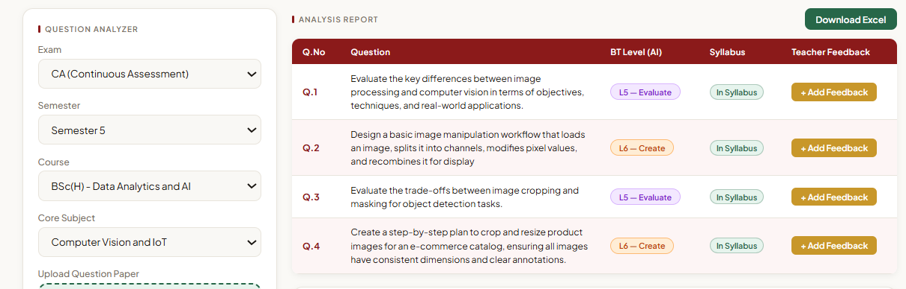

Figure 9: Question Analyzer — BT Level Results

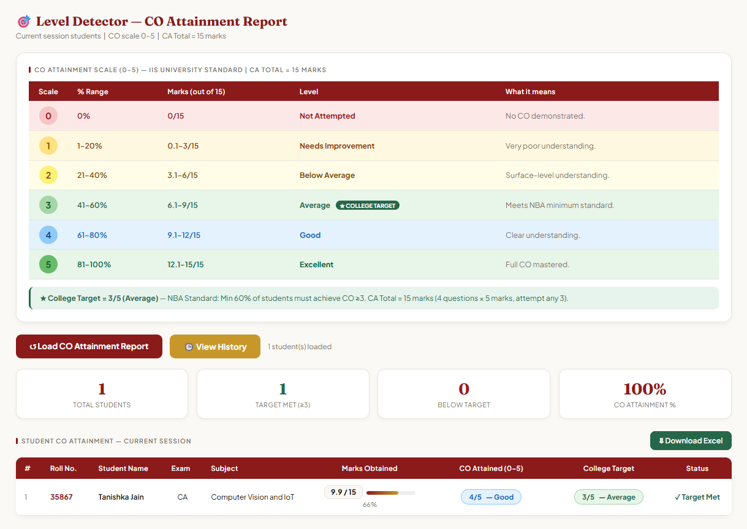

Figure 10: Level Detector — CO Attainment Report

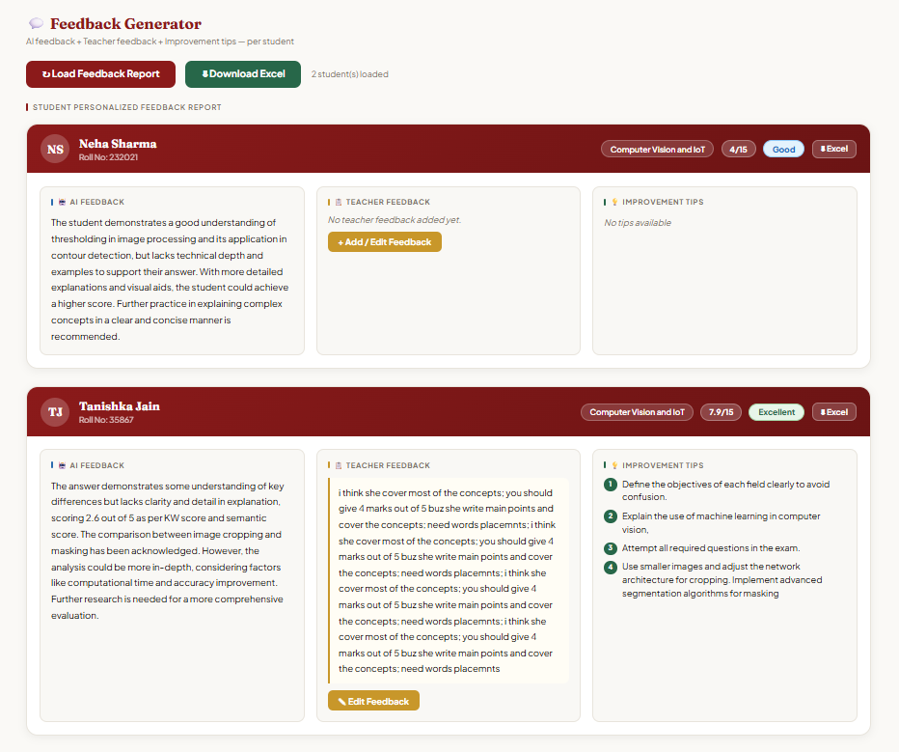

Figure 11: Feedback Generator — Student Feedback Container

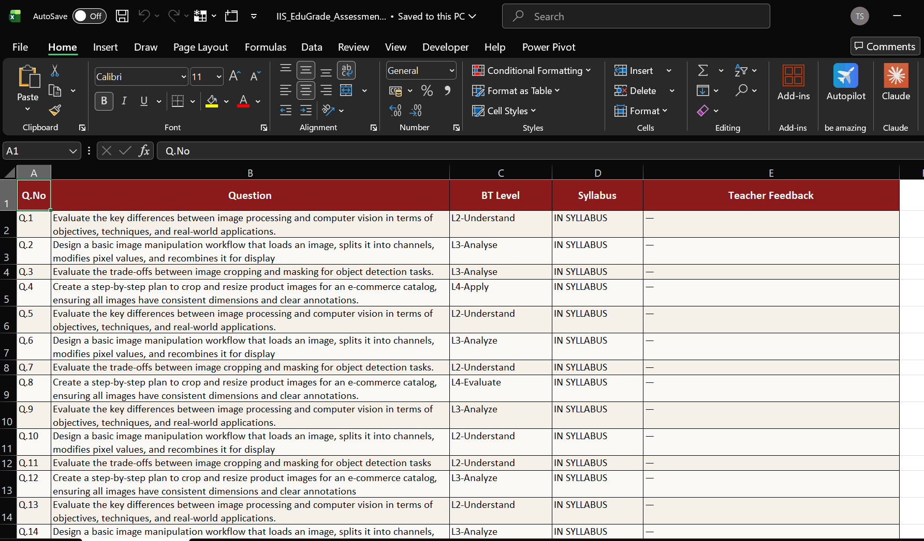

Figure 12: Downloaded Excel Report

Interpretations

After testing the system with real Semester 5 question papers and student answer sheets, the following was observed:

- Most CA questions analyzed by the system fell under L2 (Understand) and L3 (Apply) Bloom's levels, showing that assessments focus more on understanding and application than higher-order thinking.

- The keyword scoring agent correctly identified matched and missing concepts in student answers, making it easy to see exactly what a student covered and what was missing.

- Students who wrote detailed answers with correct terminology scored higher on both keyword and semantic scores, confirming the scoring formula works as expected.

- The CO attainment report clearly showed which students met the college target of 3/5 and which needed improvement, giving teachers actionable data.

Learning Outcomes

Python Programming
Proficiency in Python improved significantly, especially in writing clean backend logic,
handling file uploads, processing API responses, and managing database operations.

Flask Framework
Gained hands-on experience in building a complete web application using Flask, including setting up routes, managing user sessions, handling GET and POST requests, and connecting frontend forms to backend logic.

AI and Generative AI
Learned to integrate Google Gemini 2.0 Flash API for real tasks — using Vision AI to read images, crafting effective prompts for each agent, and parsing structured AI responses.

Multi-Agent System Design
Understood how to break a complex task into smaller specialized agents, each with a focused role, and how to combine their outputs for a final result.

Explainable AI (XAI)
Learned the importance of making AI decisions transparent and how to design prompts that return not just scores but reasons, so teachers can understand and trust the system.

Database Management
Gained experience in designing SQLite database tables, writing queries for insert and select operations, and managing relational data across multiple tables.

Web Development
Improved skills in HTML, CSS, and JavaScript for building multi-page web applications with forms, modals, dynamic tables, and chart visualizations.

Excel Report Generation
Learned to use OpenPyXL to programmatically generate formatted Excel files from database records

CONCLUSION

The development of the Multi-Agent AI Assessment System represents a significant step towards automating and improving the quality of academic evaluation at IIS (Deemed to be University). By combining Vision AI, four specialized AI agents, and Explainable AI features, the system provides teachers with fast, consistent, and transparent question paper analysis and student answer evaluation. The use of Bloom's Taxonomy detection ensures that question papers maintain academic quality, while the multi-agent evaluation pipeline ensures that student answers are assessed on both keyword coverage and deeper understanding. The human-AI collaboration feature, where teachers can override AI marks and add feedback, ensures that the final decision always remains with the teacher. This project serves as a model for how AI can be used responsibly and transparently in educational assessment.

IIS Edu Grade AI shows how AI can improve academic assessment when used thoughtfully in a university setting. By combining Vision AI, a four-agent evaluation pipeline, Bloom's Taxonomy detection, and NBA-aligned CO attainment tracking, the system provides fair and consistent results for both teachers and students. Teachers get clear insights into question quality and student performance. Students can log in independently and view their personalized feedback. This system is a practical step toward outcome-based, data-driven education at IIS University.

REFERENCES

- Anderson, L. W., & Krathwohl, D. R. (2001). A Taxonomy for Learning, Teaching, and Assessing: A Revision of Bloom's Taxonomy of Educational Objectives. Longman.

- Google Gemini API Documentation. (2024). Google AI for Developers. https://ai.google.dev/

- Palomino, M., & Taylor, J. (2022). Automated Assessment Systems in Higher Education: A Review. Journal of Educational Technology, 18(2), 45-60.

- Flask Documentation. (2024). Pallets Projects. https://flask.palletsprojects.com/

- OpenPyXL Documentation. (2024). https://openpyxl.readthedocs.io/

ANNEXURE

Project File Structure

The following table describes all the files used in the IIS EduGrade AI project and their role in the system:

File Name | Type | Description
app.py | Python | Main backend file. Contains all Flask routes, database logic, session management, and Anthropic Claude API calls for all four agents.
home.html | HTML | Landing page of the system. Shows project introduction and navigation links to teacher and student login.
assess.html | HTML | Main assessment page for teachers. Contains the Question Analyzer tab where teachers upload question papers and view BT level analysis results.
answer_evaluator.html | HTML | Answer Evaluator tab. Handles student PDF upload, displays four-agent pipeline results, keyword and semantic scores, and total marks out of 15.
level_detector.html | HTML | Level Detector tab. Shows student-wise Course Outcome attainment report on 0–5 scale as per NBA accreditation standards.
feedback_generator.html | HTML | Feedback Generator tab. Displays each student's overall AI feedback, teacher feedback, and improvement tips in a separate container.
assess_base.html | HTML | Base template for all assessment tabs. Contains common header, navigation bar, and maroon gold color styling.
login.html | HTML | Teacher login page with email and password form. Creates Flask session on successful login.
register.html | HTML | Teacher registration page with name, department, course, email, and password fields.
student_login.html | HTML | Student login page. Students log in using their roll number and password.
student_register.html | HTML | Student registration page with name, roll number, course, email, and password fields.
student_dashboard.html | HTML | Student dashboard. Shows only the logged-in student's own AI feedback, teacher feedback, and improvement tips.
reset_password.html | HTML | Password reset page for both teachers and students.
edugrade.db | SQLite | Main database file storing all user accounts, question analysis results, teacher feedback, and student evaluation records.

Home.html

<!DOCTYPE html>

<html lang="en">

<head>

<meta charset="UTF-8"/>

<meta name="viewport" content="width=device-width,initial-scale=1"/>

<title>IIS EduGrade AI</title>

<link href="https://fonts.googleapis.com/css2?family=Fraunces:wght@400;600;700&family=Plus+Jakarta+Sans:wght@400;500;600;700&display=swap" rel="stylesheet"/>

<style>

*,*::before,*::after{box-sizing:border-box;margin:0;padding:0}

:root{--maroon:#8B1A1A;--maroon-dark:#6b1414;--gold:#C8972A;--gold-light:#e8b843;--bg:#faf9f6;--surface:#fff;--border:#e8e4dc;--text:#1a1612;--muted:#7a7268;}

body{font-family:'Plus Jakarta Sans',sans-serif;background:var(--bg);color:var(--text);}

/* NAV */

nav{background:var(--surface);border-bottom:2px solid var(--maroon);padding:0 2.5rem;display:flex;align-items:center;justify-content:space-between;height:70px;position:sticky;top:0;z-index:100;box-shadow:0 2px 12px rgba(0,0,0,0.08)}

.nav-brand{display:flex;align-items:center;gap:0.85rem}

.nav-logo{width:46px;height:46px;object-fit:contain;border-radius:6px;}

.nav-logo-fb{width:46px;height:46px;background:var(--maroon);border-radius:8px;display:none;align-items:center;justify-content:center;color:#fff;font-weight:700;font-size:14px;}

.nav-text h1{font-family:'Fraunces',serif;font-size:1.1rem;font-weight:700;color:var(--maroon);}

.nav-text p{font-size:0.68rem;color:var(--muted);text-transform:uppercase;}

.nav-btns{display:flex;gap:0.6rem;align-items:center;}

.btn-o,.btn-f{padding:0.5rem 1.2rem;border-radius:8px;font-size:0.82rem;text-decoration:none;font-weight:600}

.btn-o{border:1.5px solid var(--maroon);color:var(--maroon)}

.btn-o:hover{background:var(--maroon);color:#fff}

.btn-f{background:var(--maroon);color:#fff;border:1.5px solid var(--maroon)}

.register-dropdown .login-dropdown-btn{background:var(--maroon);color:#fff !important;}

.register-dropdown .login-dropdown-btn:hover{background:var(--maroon-dark);color:#fff !important;}

.btn-f:hover{background:var(--maroon-dark)}

/* LOGIN DROPDOWN */

.login-dropdown{position:relative;display:inline-block;}

.login-dropdown-btn{padding:0.5rem 1.2rem;border-radius:8px;font-size:0.82rem;font-weight:600;border:1.5px solid var(--maroon);color:#fff;background:var(--maroon);cursor:pointer;display:flex;align-items:center;gap:0.4rem;font-family:inherit;}

.login-dropdown-btn:hover{background:var(--maroon-dark);color:#fff;}.login-dropdown-btn:hover{background:var(--maroon);color:#fff;}

.login-dropdown-menu{position:absolute;top:calc(100% + 6px);right:0;background:var(--surface);border:1.5px solid var(--border);border-radius:10px;box-shadow:0 8px 24px rgba(0,0,0,0.12);min-width:180px;z-index:999;display:none;overflow:hidden;}

.login-dropdown-menu.open{display:block;}

.login-menu-item{display:block;padding:0.75rem 1rem;font-size:0.82rem;font-weight:600;color:var(--text);text-decoration:none;transition:background 0.15s;}

.login-menu-item:hover{background:#faf0f0;color:var(--maroon);}

.login-menu-divider{height:1px;background:var(--border);margin:0;}

.login-menu-label{padding:0.4rem 1rem;font-size:0.68rem;color:var(--muted);text-transform:uppercase;letter-spacing:0.05em;background:#faf9f6;}

/* REGISTER DROPDOWN */

.register-dropdown .login-dropdown-btn{background:var(--maroon) !important;color:#fff !important;}

.register-dropdown .login-dropdown-btn:hover{background:var(--maroon-dark) !important;color:#fff !important;}

.register-dropdown{position:relative;display:inline-block;}

.register-dropdown-menu{position:absolute;top:calc(100% + 6px);right:0;background:var(--surface);border:1.5px solid var(--border);border-radius:10px;box-shadow:0 8px 24px rgba(0,0,0,0.12);min-width:180px;z-index:999;display:none;overflow:hidden;}

.register-dropdown-menu.open{display:block;}

/* HERO */

.hero{background:linear-gradient(135deg,var(--maroon),var(--maroon-dark));color:#fff;padding:4rem 2.5rem;text-align:center;animation:fadeIn 1s ease;}

.hero h2{font-family:'Fraunces';font-size:2.5rem;}

.hero span{color:var(--gold-light)}

.hero p{opacity:0.9;margin-top:12px;max-width:600px;margin-left:auto;margin-right:auto;line-height:1.7;}

/* IMAGE */

.img-section{padding:2.5rem;max-width:1100px;margin:auto}

.img-row{display:grid;grid-template-columns:repeat(3,1fr);gap:1rem}

.img-card{border-radius:14px;overflow:hidden;transition:0.4s;}

.img-card:hover{transform:translateY(-6px) scale(1.02);}

.img-card img{width:100%;height:100%;object-fit:cover}

.img-caption{text-align:center;padding:0.6rem 0.4rem 0.3rem;font-size:0.82rem;font-weight:700;color:var(--text);}

/* ABOUT */

.about{background:var(--surface);padding:2.5rem;margin-top:2rem;animation:fadeUp 1s ease;}

.about-inner{max-width:1100px;margin:auto;display:grid;grid-template-columns:1fr 1.4fr;gap:2rem;align-items:center;}

.about h3{font-family:'Fraunces';font-size:1.5rem;margin-bottom:10px;}

.stats-grid{display:grid;grid-template-columns:repeat(3,1fr);gap:1rem;margin-top:10px;}

.stat{background:var(--bg);border:1px solid var(--border);border-radius:12px;padding:1rem;text-align:center;transition:0.3s;}

.stat:hover{transform:translateY(-5px);box-shadow:0 10px 25px rgba(139,26,26,0.15);}

.stat-num{font-size:1.5rem;font-weight:700;color:var(--maroon);}

.stat-label{font-size:0.7rem;color:var(--muted);margin-top:5px;}

/* FEATURES */

.features{padding:3rem;text-align:center}

.feat-grid{display:grid;grid-template-columns:repeat(2,1fr);gap:2rem;margin-top:2rem;}

.feat-card{padding:2.5rem;border-radius:16px;background:white;transition:0.4s;box-shadow:0 8px 25px rgba(0,0,0,0.08);cursor:pointer;}

.feat-card:hover{transform:translateY(-8px);background:#faf0f0;}

.feat-title{font-size:1.2rem;font-weight:700;margin-bottom:10px;}

.try-btn{display:inline-block;margin-top:12px;padding:8px 18px;background:var(--maroon);color:#fff;border-radius:8px;font-size:0.8rem;text-decoration:none;}

.try-btn:hover{background:var(--maroon-dark);}

.extra{padding:3rem;text-align:center;color:var(--muted);}

footer{background:var(--maroon);color:#fff;text-align:center;padding:1rem;margin-top:2rem;}

@keyframes fadeIn{from{opacity:0}to{opacity:1}}

@keyframes fadeUp{from{opacity:0;transform:translateY(20px)}to{opacity:1;transform:translateY(0)}}

</style>

</head>

<body>

<nav>

<div class="nav-brand">

<img src="{{ url_for('static', filename='iisu_logo.jpg') }}" class="nav-logo"

onerror="this.style.display='none';document.getElementById('lfb').style.display='flex'">

<div class="nav-logo-fb" id="lfb">IIS</div>

<div class="nav-text">

<h1>IIS EduGrade AI</h1>

<p>IIS (Deemed to be University), Jaipur</p>

</div>

</div>

<div class="nav-btns">

<!-- LOGIN DROPDOWN -->

<div class="login-dropdown" id="loginDropdown">

<button class="login-dropdown-btn" onclick="toggleDropdown('loginDropdown')">

Login ▾

</button>

<div class="login-dropdown-menu" id="loginDropdownMenu">

<div class="login-menu-label">Login as</div>

<div class="login-menu-divider"></div>

<a href="/login" class="login-menu-item">👩‍🏫 Teacher Login</a>

<div class="login-menu-divider"></div>

<a href="/student-login" class="login-menu-item">👩‍🎓 Student Login</a>

</div>

</div>

<!-- REGISTER DROPDOWN -->

<div class="register-dropdown" id="registerDropdown">

<button class="login-dropdown-btn btn-f" onclick="toggleDropdown('registerDropdown')" style="color:#fff;border-color:var(--maroon);">

Create Account ▾

</button>

<div class="register-dropdown-menu" id="registerDropdownMenu">

<div class="login-menu-label">Register as</div>

<div class="login-menu-divider"></div>

<a href="/register" class="login-menu-item">👩‍🏫 Teacher Account</a>

<div class="login-menu-divider"></div>

<a href="/student-register" class="login-menu-item">👩‍🎓 Student Account</a>

</div>

</div>

</div>

</nav>

<div class="hero">

<h2>Smart Grading for the <br><span>Next Generation</span></h2>

<p>Our AI-powered system evaluates student answers using advanced natural language processing, semantic analysis, and multi-agent intelligence. It provides accurate scoring, identifies concept understanding, and generates personalized feedback instantly — making assessment faster, transparent, and smarter.</p>

</div>

<div class="img-section">

<div class="img-row">

<div class="img-card">

<img src="{{ url_for('static', filename='img2.jpg') }}">

<div class="img-caption">IISU Campus</div>

</div>

<div class="img-card">

<img src="{{ url_for('static', filename='img1.jpg') }}">

<div class="img-caption">Academics &amp; Student Life</div>

</div>

<div class="img-card">

<img src="{{ url_for('static', filename='img3.png') }}">

<div class="img-caption">Information Technology &amp; Innovation</div>

</div>

</div>

<div class="about">

<div class="about-inner">

<div>

<h3>IIS (Deemed to be University), Jaipur</h3>

<p>Established in 1995, IIS University is Rajasthan's premier women's university, accredited NAAC A+ and recognized by UGC.</p>

</div>

<div class="stats-grid">

<div class="stat"><div class="stat-num">1995</div><div class="stat-label">Established</div></div>

<div class="stat"><div class="stat-num">80+</div><div class="stat-label">Programs</div></div>

<div class="stat"><div class="stat-num">14</div><div class="stat-label">Departments</div></div>

<div class="stat"><div class="stat-num">4500+</div><div class="stat-label">Students</div></div>

<div class="stat"><div class="stat-num">NAAC A+</div><div class="stat-label">Accreditation</div></div>

<div class="stat"><div class="stat-num">30 Acre</div><div class="stat-label">Campus</div></div>

</div>

</div>

</div>

<div class="features">

<h3>What EduGrade AI Does</h3>

<div class="feat-grid">

<div class="feat-card" onclick="location.href='/assess'">

<div class="feat-title">🔍 Question Analyzer</div>

<a href="/assess" class="try-btn">Try It</a>

</div>

<div class="feat-card" onclick="location.href='/answer-evaluator'">

<div class="feat-title">📊 Answer Evaluator</div>

<a href="/answer-evaluator" class="try-btn">Try It</a>

</div>

<div class="feat-card" onclick="location.href='/level-detector'">

<div class="feat-title">🎯 Level Detector</div>

<a href="/level-detector" class="try-btn">Try It</a>

</div>

<div class="feat-card" onclick="location.href='/feedback-generator'">

<div class="feat-title">💬 Feedback Generator</div>

<a href="/feedback-generator" class="try-btn">Try It</a>

</div>

</div>

</div>

<div class="extra">

<p>Empowering smarter education through AI-driven evaluation systems designed for modern learning environments.</p>

</div>

<footer>

<strong>IIS EduGrade AI</strong> — IIS University, Jaipur

</footer>

<script>

function toggleDropdown(id) {

var loginMenu = document.getElementById('loginDropdownMenu');

var registerMenu = document.getElementById('registerDropdownMenu');

if (id === 'loginDropdown') {

loginMenu.classList.toggle('open');

registerMenu.classList.remove('open');

} else {

registerMenu.classList.toggle('open');

loginMenu.classList.remove('open');

}

}

// Close dropdowns when clicking outside

document.addEventListener('click', function(e) {

var ld = document.getElementById('loginDropdown');

var rd = document.getElementById('registerDropdown');

if (!ld.contains(e.target)) document.getElementById('loginDropdownMenu').classList.remove('open');

if (!rd.contains(e.target)) document.getElementById('registerDropdownMenu').classList.remove('open');

});

</script>

</body>

</html>

